**Experiment 1**

**Aim:**

To study Linear Basis Functions Models for regression

**Objective:**

1. To fit a line to the given data using Polyfit function.
2. To fit a polynomial to the given data using Polyfit function.
3. Observe effect of increasing the order of polynomial on the mean squared error.

**Software platform:**

Matlab

**Theory:**

* **Linear Regression:**

Linear regression is an approach for modeling relationship between a scalar dependent variable y and one or more independent variables. When there is single independent variable it is called simple linear regression and when there are more than one independent variables it is called multiple linear regression. Linear regression is a statistical procedure for predicting the value of a dependent variable from an independent variable when the relationship between the variables can be described with linear model given by y = m * x + c.

* **Linear Regression Using Basis Functions**

Given data points (x1, y1),(x2, y2), . . . ,(xN , yN ) where x∈X and y∈R, the task of regression is to fit a real valued function *f* : X → R to these points. In the simplest case X = R. In multidimensional regression X = R*. It is sometimes necessary to do regression on more complicated spaces, but we are not going to deal with that here.

The easiest way to attack the regression problem is to look for *f* in a finite dimensional space of functions spanned by a given basis. In other words, we specify a set of functions φ0, φ1, . . . , φP from X to R and look for *f* in the form of a linear combination.

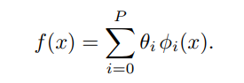

Performing the regression, then reduces to finding the real parameters θ1, θ2, . . . , θP .

**Different types of Basis functions**

**Linear regression:**

The simplest case is that of linear regression. In the one dimensional case we would simply take φ0(x) = 1 and φ1(x) = x. This gives

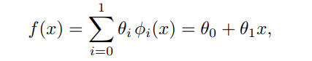

**Polynomial regression:**

Another possible choice of basis (in the one-dimensional case) is to set φi(x) = x^i for i = 1, 2, . . . , P. This lets us choose f from the class of polynomial functions of degree at most P:

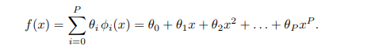

**Algorithm1 (Objective 1):**

1. Create data of 100 samples (x, t) which have approximately linear relationship and plot y vs x. (y = mx + c + random number)
2. Use polyfit() function to get the value of weights w0, w1.
3. Use polyval() function to get the predicted value y1 for input x1 by using weights obtained by polyfit() function.
4. Plot y1 vs x.
5. Find the mean square error by:
   * 1. E = mean ((y-y1).^2

**Algorithm2 (Objective 2):**

**Conclusion:**

**FAQ’S:**

1. Give advantages and limitations of linear regression model.
2. Explain the importance of cost function in regression.
3. Compare linear and nonlinear regression.
4. Explain types of basis functions used in regression other than polynomial basis function.